**Assignment - 5**

Q1. Describe MVC architecture in details .

MVC is abbreviated as **Model View Controller** is a design pattern created for developing applications specifically web applications. As the name suggests, it has three major parts. The traditional software design pattern works in an "Input - Process - Output" pattern whereas MVC works as "Controller -Model - View" approach.

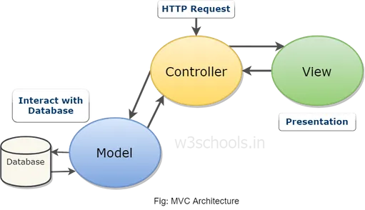

**Model**: The Model encloses the clean application related data. But the model does not deal with any logic about how to present the data

**View**: The View element is used for presenting the data of the model to the user. This element deals with how to link up with the model's data but doesn't provide any logic regarding what this data all about or how users can use these data.

**Controller**: The Controller is in between the model and the view element. It listens to all the incident and actions triggered in the view and performs an appropriate response back to the events.

The different versions of MVC later came into existence with the requirement for application designing. These are:

* Hierarchical model-view-controller (HMVC).
* Model-view-presenter (MVP).
* Model-view-adapter (MVA).

Model-view-viewmodel (MVVM) and some others.

**Q2. List and Describe Feature of angular js.**

**1.The  MVC Architecture is Perfect**

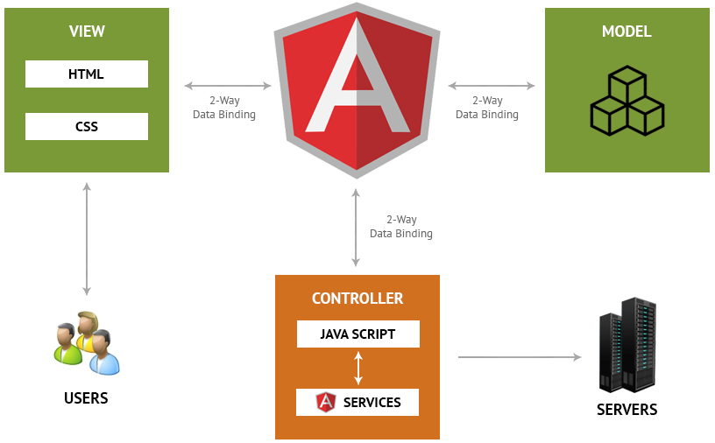

MVC stands for Model View  Architecture which is a software pattern to develop applications. The model layer manages the application data, the view layer is responsible for the display of this data while the controller is what connects the model and the view layer.

**2. Unit Testing assures Quality Code**

One of the best features of angularjs is the fact that it makes use of a unit testing technique that helps user produce high quality applications. The code is divided into the smallest testable parts i.e. units. This also helps you easily detect any flaws or mistakes in each line of the code.

**3. Data Binding is Efficient**

Data binding in AngularJS is a two way street. This means that the view layer of the architecture is always an exact representation of the model. Unlike in other applications, the model and view layers are continuously updated to remain in sync with one another.

So any changes you make in your model layer will automatically be reflected in your view layer and vice versa. This again saves a significant amount of time in coding the connection between the two whenever a change is made.

**4. Requires Writing Less Code**

As is made clear by the above characteristics, AngularJS needs a lot less coding than others. You don’t have to write code to connect the MVC layers, you don’t have to write separate codes for the view manually, directives are separate from the app code and can be written parallelly etc. All of these collectively decrease the amount of coding that is required, significantly. This also saves up your developer costs making your AngularJS hiresthe most cost effective.

**5. It is developed by Google:**

Google is the pioneer of the internet age and you know when there’s something that Google develops, it will be great. AngularJS is maintained by a dedicated team of highly skilled engineers who are readily available to solve any issues related to the framework. Since this also provides a large community to learn from, you can also find a number of highly skilled and expert AngularJS developers  spread across the world to assist you.

Although the list could go on, these 5 features are compelling enough to prove the point. AngularJS has become the dominant JavaScript framework in the world of professional web development. It helps you create a powerful and unique web application that is yet easy to use and maintain. Given these advantages, it definitely becomes hard not to prefer AngularJS for your projects.

3.) List and Describe various directives of angular js .

AngularJS facilitates you to extend HTML with new attributes. These attributes are called directives.

There is a set of built-in directive in AngularJS which offers functionality to your applications. You can also define your own directives.

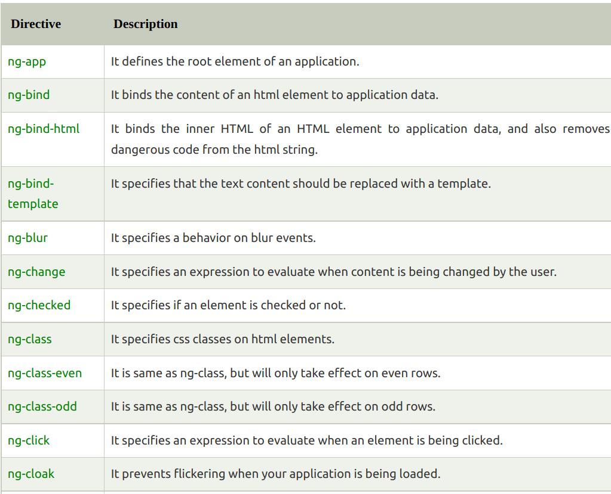Directives are special attributes starting with ng- prefix.

Q4. What are expression in angular js ? Explain various

expression in details.

AngularJS expressions can be written inside double

braces: {{ expression }}.

❖ AngularJS expressions can also be written inside a directive: ng-

bind="expression".

❖ AngularJS will resolve the expression, and return the result exactly where

the expression is written.

❖ AngularJS expressions are much like JavaScript expressions: They

can contain literals, operators, and variables.

Example code:

<!DOCTYPE html>

<html>

<body>

<div ng-app=" " ng-init=" firstName='Henil';lastName='code' ">

<p>The full name is: {{ firstName + " " + lastName }}</p>

</div>

</body>

<script src = "https://ajax.googleapis.com/ajax/libs/angularjs/1.3.14/angular.min.js"> </script>

</html>

Q5. List and Describe some of the filters used in angular js .

AngularJS Filters allow us to format the data to display on UI without

changing original format.

Filters can be used with an expression or directives using pipe | sign.

{{expression | filterName:parameter }}

•Currency: Format a number to a currency format.

•Date : Format a date to a specified format.

•filter :Select a subset of items from an array.

•json :Format an object to a JSON string.

•limitTo :Limits an array/string, into a specified number of

elements/characters.

•lowercase :Format a string to lower case.

•number :Format a number to a string.

•orderBy :Orders an array by an expression.

•uppercase :Format a string to upper case.